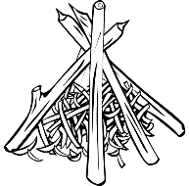Campfire Cupcake Instructions

- Create your roasting stick by cutting off one end of the toothpick just below the point.
- Carefully cut and shape one marshmallow to become the miniature marshmallows on your roasting stick.
- Using yellow and red food coloring, dye the frosting orange (this will become your fire.)
- Spoon frosting into a piping bag.
- Apply frosting to your cupcake. (You may experiment with different tips to create your desired “fire” look.) Frosting should be mounded to form a triangular shape.
- Using pretzels, create your firewood tipi surrounding your frosting fire. Pretzels should be inserted ¼ inch into the cupcake and the tips of each pretzel should meet in the middle.
- If your pretzels do not appear to be stable add one drop of frosting in the middle of the tips to hold them more firmly together. (Be careful not to add too much, as this will change the appearance of the overall product.)
- Add your roasting stick to your cupcake as desired (In the flame, across the ground, with the handle of the roasting stick inserted into the cupcake, etc.).

