FCCLA
Family, Career, and Community Leaders of America
- FCCLA is a nonprofit national vocational student organization for young men and women in family and consumer sciences education in public and private school through grade 12.
- FCCLA is the only in-school student organization with the family as its center focus.
- Involvement in FCCLA offers members the opportunity to expand their leadership potential and develop necessary life skills-planning, goal setting, problem solving, decision making and interpersonal communication-in the home and workplace.
- Chapter projects focus on a variety of youth concerns, including: Teen pregnancy, Parenting, Family relationships, Substance abuse, Peer pressure, Environment, Nutrition and fitness, Teen violence, and Career exploration.
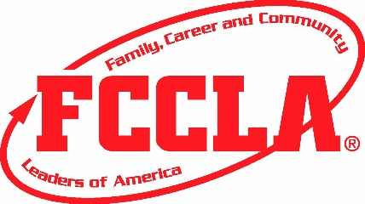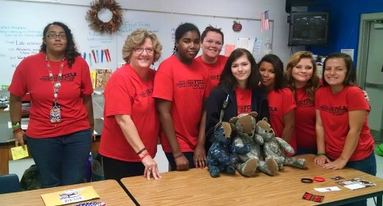
FCCLA
Family, Career, and Community Leaders of America
- FCCLA is a nonprofit national vocational student organization for young men and women in family and consumer sciences education in public and private school through grade 12.
- FCCLA is the only in-school student organization with the family as its center focus.
- Involvement in FCCLA offers members the opportunity to expand their leadership potential and develop necessary life skills-planning, goal setting, problem solving, decision making and interpersonal communication-in the home and workplace.
- Chapter projects focus on a variety of youth concerns, including: Teen pregnancy, Parenting, Family relationships, Substance abuse, Peer pressure, Environment, Nutrition and fitness, Teen violence, and Career exploration.
