What is FCS?  Family and Consumer Sciences is the comprehensive body of skills, research, and knowledge that helps people make informed decisions about their well-being, relationships, and resources to achieve optimal quality of life. The field represents many areas, including human development, personal and family finance, nutrition and wellness, textiles and apparel, and consumer issues. Today’s FCS professionals practice in multiple settings. They are early childhood, elementary, secondary, university/college, and extension educators, administrators and managers, human service professionals, researchers, community volunteers, business people, and consultants who address the issues most important to our quality of life. (http://www.aafcs.org/AboutUs/FCS.asp, Jan.2015)  Obesity Prevention Workforce  Development Personal Financial  Literacy Work-life Balance Rigor  Parenting Education Human Needs  Relevance Critical Thinking | Workforce Connections  Administrations and human services careers  Expansion of the need for dependent care, prevention and wellness education  Hospitality, tourism, and travel industries are growing in many states across the nation  Food manufacturing companies seek FCS Graduates to work in product development, consumer affairs public policy, marketing and research.  Counselors needed to work with individuals in family crisis centers  FACS educators and early childhood professionals continue to be needed to prepare our youth as family members and professionals.  #WhyIFCS | Family& Consumer Sciences  - A gateway to high demand professions
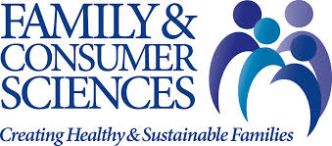  Some Classes Offered  - Home & Family Management  - Textiles  - Intro to Food Prep  - Interior Design  - Clothing Construction  - Fashion Design and merchandising  - Home Décor  - Money Management  - Practical Homemaking  - Advanced Sewing Construction  - Children’s Clothing Design  - Food Service Management  - Fitting and Alteration  - Food Safety & Sanitation  - Food Science  - Meal Management | Mission Statement  Professionals in family and consumer sciences are guided by a commitment to enhance the well-being of individuals, families, and communities by enabling individuals and families to reach their own goals and by helping to influence and shape societal change that will enhance the human condition  “I love FCS because of the practicality of the skills I have learned. I’m learning how to be a better adult!”- Alex Smith  Contact Us  Home and Family Department  Clarke 223 496-4000  www.byui.edu/home-family | 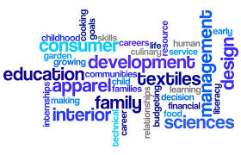  FCS on Campus  BYUI’s FCS department has grown immensely in the last few years. Education was the only major, aimed towards students who want to go into the education field, teaching secondary education. In the in recent years, they have expanded to include extension, offering careers that enable you to work in your community. Catering and Event Planning, perfect for event planners, and Apparel Entrepreneurship, giving students opportunities to learn about sewing and work in the fashion industry

