Paper Snowball Fight!
Home / Active / Paper Snowball Fight!
Paper Snowball Fight requires no real snow — it’s all about recreating a wintery fashioned snowball fight any time during the year! It is generally played in larger groups of friends but can be adjusted to fit a medium sized group as well. There are a few different you can play from the base game and it’s fun to mix things up. The snowballs are fun and easy to make on top of costing you next to nothing!

Materials Needed
- Paper
- Paint or markers
- Glue
- Cardboard

How To Set Up The Game
Divide the player group into two teams. Afterward, use the resources to create a large pile of “snowballs” and select a large area to set up in. To create the snowballs take sheets of paper you have laying around and roll them into a ball, drop a little bit of glue in each one to ensure the snowball is held together well. Afterward use two different colors to mark the team’s snowballs and begin setting up the cover. If you don’t have natural cover use the cardboard to set up fake snow banks for the players to hide behind while planning their next move.

How To Play Paper Snow Ball Fight!
To play split the players up on the field and give both sides and equal allotment of snowballs. The teams will have to stay behind a point or line that you can easily mark with a piece of cardboard at the start of the fight. Once started each team has to try to get the players out by hitting them with snowballs the team with the last player standing wins. If either team runs out of snowballs they will then switch colors as soon as the other team is empty or they stay in hiding for an amount of time that would force the game into a stand still.
For a variation of this game, you can set up a capture the flag type scenario for your players. To do this simply use paper and cardboard to make a mock flag and put it in the center of the field. The team who is first to successfully get the flag into the back of their base wins. To make the game run smoother don’t be afraid to place paper X’s where the flag goes.

How To Win
To win, simply take your time when in the game. Try to grab a stock of snowballs from the start and find cover, make sure to pay attention to your surroundings. If you can wait patiently for an opening then your team has a higher chance for success. If you find yourself playing capture the flag, then you may want to gauge who the most nimble member of your team is. Someone who is quick on their feet is less likely to get taken out by a snowball and return with the flag. Always be vocal with your teammates and make sure you are on the same page during and before the game for your best results.

Beach Ball Get-To-Know-You
Start out with a regular inflatable beach ball:
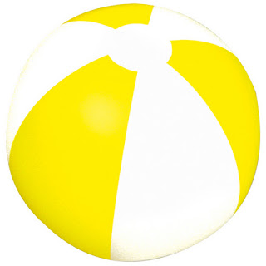

Then I write a bunch of get-to-know you questions all over it:
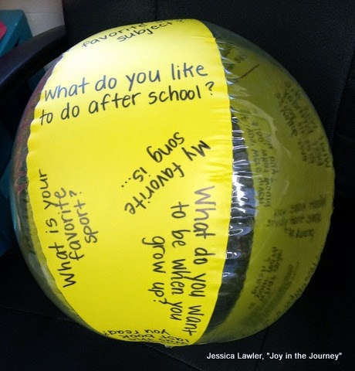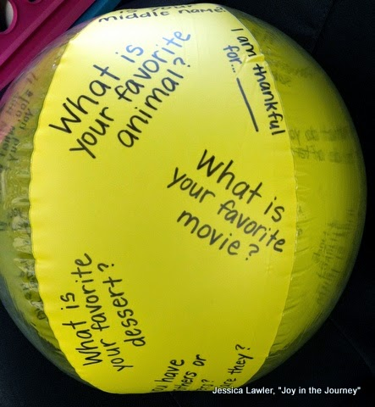
Gathered in a circle inside or outside.
Student throw the ball to a classmate and wherever their right thumb lands, that is the question they have to answer.
